- Mirafra Benguluru ( 24th april 2025 14:45 ) (Rejected)
- Tell me about your self or introduce your self
- What Is your latest project done and explain it.
- What are the peripherals you used in the project and which peripheral do you developed.
- How you initialize the UART.
- In UART master slave concept is there? And is UART is synchronous or asynchronous.
- Tell me about I2C, what are the issues you encountered.
- What is the below C programs outputs for the below codes,
#define ADD(Y) Y*Y
int main()
{
/*Mirafra bengulu Q-1*/
int q;
q=ADD(10+20)/5;
printf("value in Q= %d", q);
/*Mirafra bengulu Q-2*/
int a=4001;
uint32_t *ptr1=&a;
char *ptr2=(char*)ptr1;
printf("\n Value in ptr2 =%d",*ptr2);
return 0;
}

Feedback:
- Try to answer the question short and directly.
- Need to Improve C programming.

- Eximitas Benguluru ( 24th april 2025 18:10 ) (Rejected)
- Tell me about your self or introduce your self
- What Is your latest project done and explain it.
- What are the major issue you observed and solved.
- Print the second largest number in given unsorted array[]
int nums[]={7,10,1,2,20,3,4,5,6};
int len=sizeof(nums)/sizeof(nums[0]);
int Max1=0,Max2=0;
for (int i=0;i<len;i++){
if(Max1<nums[i]){
Max2=Max1;
Max1=nums[i];
}
}
printf("Second largest number in a array is %d",Max2 );

- Qulcomm hydrabad ( 23th may 2025 15:00 to 18:30 ) (3.5hrs)
TR1:- (Cleared)
- Interduce your self
- Storage classess in C
- C memory layout
- Structure bit field define and what is the advantages
- What is a union
- Reverse a number
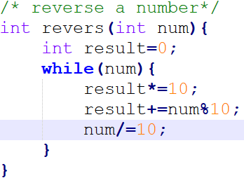
- Write a m^n code in T.C of O(log n) --> I done it in the O(n)
- Check the given number is power of 2.
- Reverse a single linked list.
- Operating systems concepts

TR2: -(Cleared)
- Write a fill and read functions for circular buffer and consider all the failure cases and try to write in optimized way.
- Reverse a given uint32 bit variable bit fields by byte wise. 0x07 -> 0000 0111 to -->1110 0000
- What happens if your code contains the while(1)
- What happens if you add a delay in the ISR.
- What is the GPIO and what are the configurable parameters.
- What happens if 2 masters try to communicate same time with slave in I2C
- What modes in the cortex-m4 , what is privileged and unprivileged modes.
- What are the difference between the I2C and SPI
- Why I2C required the pull up restores.
- What happens in the IRQ how the data moves in to the stack.
TR3:- Manager round (Rejected)
- Thread mode and handler mode
- OS concepts
- Single phase and three phase motor working principal
- How the ISR routine works, what about the temporary data which is present in the main function.

- Micro-chip Benguluru (Rejected)
TR-1 ( 02th Jun 2025 15:00 to 15:30 ) (0.5hrs)
- Interduce your self.
- Expalin about project.
- Which peripheral u used, explain it. Why you taken I2C only is there any other peripherals can use.
- What is Ur C programming ratting out of 10. 7/10.
- Write a program
input- {0 , 0 , 1 , 0 , 1, 0}
output - { 0 , 0 , 0 , 0 , 1 , 1} in O(n).
- What is the use of function pointers and what is the advantage of it.
- Where the linked list used and what are the real time examples.

- Havells Noida (Cleared)
TR-1 ( 06th Jun 2025 16:00 to 17:00 ) (1hr)
- Interduce your self.
- Expaln about your project.
- What are the issue you face.
- Function pointer and normal function difference, and the variables present in the function.
- Volitile & Constant
- What is the difference between #define & const.

- Havells Noida (Cleared)
TR-2 ( 13th Jun 2025 15:00 to 16:00 ) (1hr)
- Interduce your self.
- In which micro controllers you worked
- What is your role in your project
- How many times your product is fail in DQA.
- How the buffer management works, how did you manage if data corrupted.
- How did you implemented the FOTA, explain it.
- What did you do if received Firmware ver1.3 is more than the allotted size.
- Draw the your system basic architecture.

- Toshiba Benguluru (Rejected)
TR-1 ( 13th Jun 2025 16:00 to 18:00 ) (2hr).
- Interduce your self & in which technology you worked.
- Diffidence between M0 & M4 processors. (Not answered)
- What is little Indian and big Indian
- What is difference between global and static variables.
- Where the static variables are stored, what is the need of storing those in data area.
- What is the difference between structure and union.
- What is the watch dog what it does, what is exception and interrupt. What is the NMI number of it.
- Expalin below terms
1.const int a;
2.int const a;
3.const int *a;
4.int * const a;
5.int const * const a;

1. int *ptr(); (Forget the answer) & (Not answered)
2. int (*ptr)();
- Write a code to check its a Little or Big Indian.
- Write a program to swap the even and odd nibbles of a 32-bit integer using bit wise operations.
Input: num = 0xABABABAB;
Output: num = 0xBABABABA; (Question was not understand properly) (Not answered)
Solution: -
uint32_t Num=0xABABABAB;
Num=(((Num&0xF0F0F0F0)>>4)|((Num&0x0F0F0F0F)<<4));
printf("%X",Num);
- Array has N/2 elements filled . Duplicate each element in array without using additional storage.
Size of array = N
Input = 1,2,3,4
Output= 1,1,2,2,3,3,4,4
Complete it in without taking extra space & O(n)
(Initially write it in two for loops, after interviewer concern write it in single for loop)

- Output for give code ( Initially confused on the question and telling that syntax error, after that answer also not sad confidently )
- Output for give code for the give inputs 1 & 2.
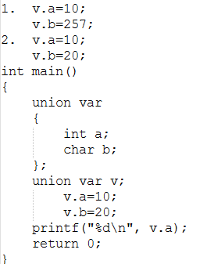
- Output for give code
enum days {MON=-1, TUE, WED=6, THU, FRI, SAT};
printf("%d, %d, %d, %d, %d, %d\n", MON, TUE, WED, THU, FRI, SAT);
- Output for give code ( Initially confused on the question and telling that o/p is 1 to 10 prints, interviewer concern I sad answer is 1 0 0 0 2 0 0 0 3 0)
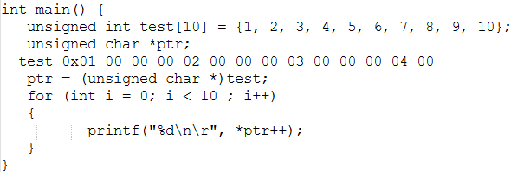
- Output for give code, Explain why ? (In which case it prints the actual value)
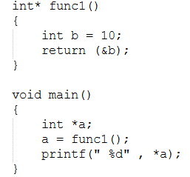
- How to measure the size of any variable without “sizeof” operator?
(Not answered, but approach was said)
Solution: -
union {
uint32_t Data_32;
uint8_t Data_8[10];
}Data1; //max size is 10
uint8_t *ptr1=(uint8_t*)&Data1;
uint8_t *ptr2=(uint8_t*)(&Data1+1);
printf("sizeof(Data1) is %ld\n",ptr2-ptr1); //sizeof(Data1) is 12 (due to padding for alignment)

- Using only a Four-minute hourglass and a seven-minute hourglass/sand glass, (Not answered)
How will you measure exactly nine minutes?
Restriction:- Without the process taking longer than nine minutes.

- Mirafra Benguluru: - TR-1 ( 20th Jun 2025 19:00 to 19:45 ) (Cleared)
- Tell me about your self shortley.
- What is the need of programming.
- How the C programming is converted to Machine code what are the steps involved in it.
(Not clearly answered)
- What is the use of extern key word & Explain real time usage. How many bytes are allocated for Extern variable.
- What are the linking time errors & what linker exactly does.
- What is mean by 32bit processor, what is the significance of 32.
- What is the maximum size of arithmetic operation done by the 32 bit processor.
- What type of communication protocol you used in your projects, explain how exactly UART communication happened in between the two devices ( mainly in the hardware point of you)
- What is the use of STOP bit in UART communication bit.
- What are the error present in the UART communication.
- What is mean by parity.
- What is the maximum bit count possible in one UART frame. (Not answered correctly)
- Write a programming to count the number of constitutive patterns matching with given pattern.
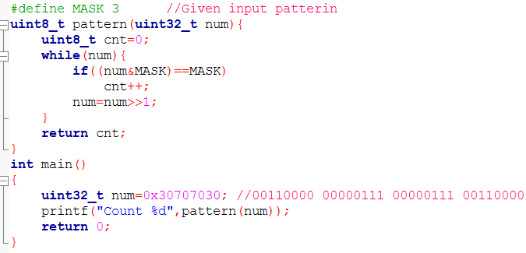
- You have any questions to Ask me. (Need to ask questions regarding JOB role and work type)

- Mirafra Benguluru: - TR-2 ( 24th Jun 2025 17:00 to 17:45 ) (Cleared)
- Tell me about your self short.
- Which protocols are you used, Explain UART functionality.
- Why IRQ numbers needed, how it advantages than compared to others.
- How to configure the SPI.
- Is it possible to use const + static, what is the application.
- suppose fun() 10 times then what value would be a
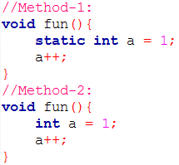
- Wap to Convert 0x12345678 to 0x78345612.
int main()
{
int num=0x12345678;
printf("revers number %X",(((num&0xFF)<<24)|((num&0xFF000000)>>24)|(num&0x00FFFF00)));
return 0;
}
Feed back:-
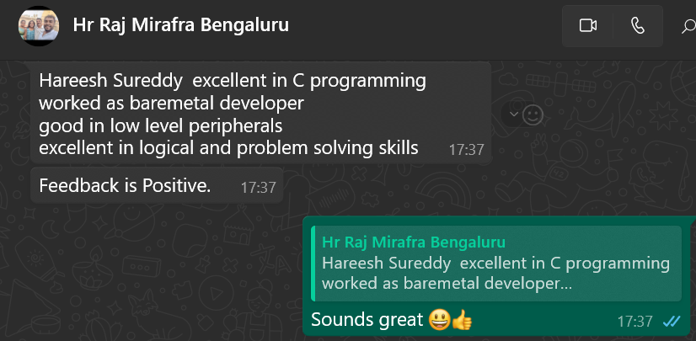

- Vayavyalabs Benguluru TR-1 ( 24th Jun 2025 18:00 to 19:05 ) (Cleared)
- Tell me about your self short.
- Explain what are the fundamental blocks in a micro controllers.
- What is memory mapped registers. (Not answered)
- What is the clock starching in I2C, how this function is works in SPI. (Not answered)
- UART working how it exactly in hardware.
- Write a data in to a given address using pointers.
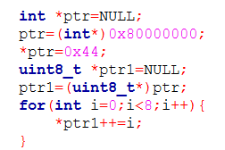

- Implémentent a stack data structure.
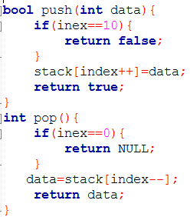
- Wap to replace the given occurrence with given number.
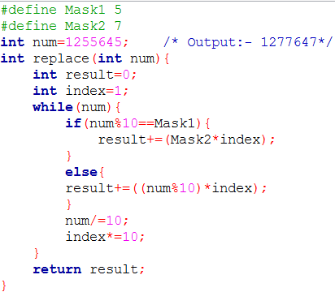
- Eximitas Benguluru TR-1( 24th Jun 2025 19:05 to 20:00) (Cleared)
- Tell me about your self short.
- What is polling.
- What is an interrupt and how exactly it works.
- How you interface thé Digital driver module to your controller.
- Multi threading, contact switching and synchronize (mute x and Semaphores) RTOS concepts.
- What are calloc and malloc functions, what is difference between them.
- Wap program to swap a nibbles of a 16 bit number.
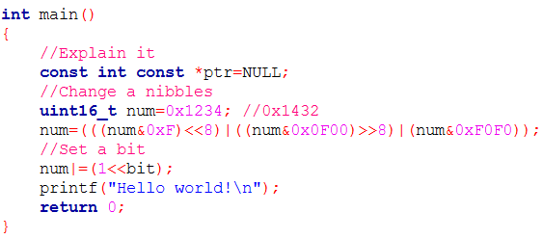
- Search a given data in a linked list, the linked list is sorted format.
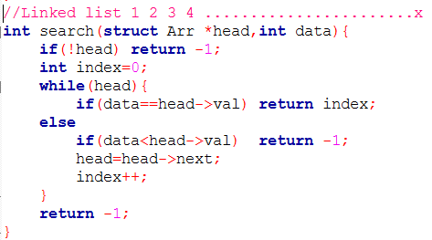
- Implémentent a stack data structure.
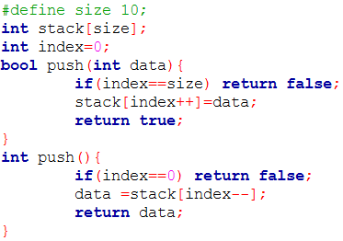
- Eximitas Benguluru TR-2:- (25th Jun 2025 21:05 to 21:40) (Cleared)
- Tell me about your self short.
- What is the reason for JOB change.
- Why your still looking for a job, you already having a 2 offers in your hand.
- What is a static key word and where it is used.
- WAP to merge a two sorted linked lists. (Not implemented correctly)


- Infineon (client Mirafra Benguluru): -( 27th Jun 2025 12:00 to 13:00 ) (Rejected)
Joined lately due to this some how mess up happened, this shouldn't repeat again.
- Tell me about your self short.
- You are in to the railway domain, how do u insure that your product is meeting RDSO standards.
- What is the purpose of watch dog, in your system Watch dog resets during the critical data reading how the RDSO approves it or how do you address this issue and how do you explain it with RDSO.
- How much time it takes to execute a main function from reset.
- How do you validate the flash and RAMs.
- Implement a C programming array of function pointers task1 ,task2 and task3
and i want to execute a task2 if the task 1 is successfully executed. (Not implemented correctly)
- Are aware of python & C++, then why you mentioned C++ in the resume.
- What are the difference between the RS485 & RS232, which one is the more speed and why.
- What are the issues u faced in the UART communication.
- What is constant and where it is stored, and is we can use const + volatile what is the use of it and where it is stored.
- How do you use string in assembly language. (Not answered)
- What CRC your are used in your system.

- Vayavyalabs Benguluru TR-2: -( 30th Jun 2025 19:00 to 20:00 ) (Cleared)
- Tell me about your self short.
- What exactly Data logger does and what are the peripheral you are used in it.
- Explain ISR how exactly works.
- What are the things we are care while implementing the ISR.
- Explain the compilation process.
- What does Linker does and what are the Linking types.
- What is the static key word and where it is used.
- How can we access a static function defined in a one .C file to the another .C file.
- 0x8000 0004, Status register address, where bit 0 will indicate that data transfer is start, wap to start the data transfer.
Uint32_t *ptr=(uint32_t*)0x80000000;
*ptr|=1;
- 0x8000 0000, Status register address, where bit 0 will indicate that data transfer is complete, wap to know the data transfer is completed.
Uint32_t *ptr1=(uint32_t*)0x80000004;
While (*ptr1&1){
}
- Reverse a given string using stack data structure with push and pop APIs
Use a character array of 256 bytes as stack and use push and pop API to insert data to this array
(Some how need to improve the communication skills, so much lagging.)

- ADI (client Mirafra Benguluru): - (1th July 2025 11:00 to 12:00) (Rejected)
- Tell me about your self short & what are the roles and responsibilities you having.
- Explain what data logger exactly does and where it is present.
- What are the major or critical bugs you are solved in your project.
- How do you implement the FOTA. If you need to change the firmware in that case how do you do that, and all data loggers firmware changes at a time how it happens.
- How you are changing the firmware in the data logger, you mentioned in the resume that you are implemented a FOTA. But your are saying manually.
- Wap to get the data from the below address of data bits 0 to 10. (didn't understand the question)
/*0x20
7 6 5 4 3 2 1 0
|-|-|-| | | | | |
<NDIV[10:8]>
0x21
7 6 5 4 3 2 1 0
|-|-|-|-|-|-|-|-|
<NDIV[7:0]>
NDIV[10:0]
*/
int reg_read(const struct device* dev, uint8_t regAddr, void* readBuff, uint8_t numBytes){
}
- An analog sensor outputs a voltage non-linearly mapped to distance,
distance = sqrt(voltage) * 10.
The sensor is connected to an 8-bit ADC with a 3.3V reference.
  - Write a function to calculate the distance from an unsigned 8-bit ADC reading.
  - Write a function to calculate the distance from an signed 8-bit ADC reading in this case voltage,
In this case voltage range is -1.6V to +1.6V.

- Qualcomm Benguluru TR-1 : - (4th July 2025 11:00 to 12:00)
- Tell me about your self short & what are the roles and responsibilities you having.
- Wap to add & delete a element in a array. Array could be dynamically allocated.
- Wap to add & delete a node in a linked list.
- Refer git-hub for remaining questions.
- Allocate a memory for integer pointers
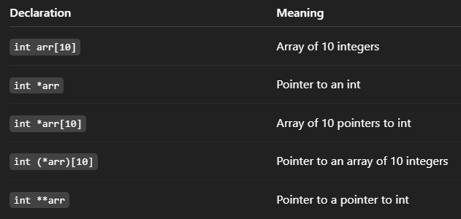

- AMD Hyderabad TR-1 : - (4th July 2025 12:05 to 13:00)
- Tell me about your self short & what are the roles and responsibilities you having.
- Explain about EI protocol converter with architecture.
- Where did you used the UART, I2C, DMA and Watch dog.
- Your dealing with Indian railways so, what are the safety measures you taken for the system while your developing. (Not answered properly)
- What are the difference between the 68K processor and ARM cortex processor.
- What is the volatile and const, where it used.
- Wap to toggle a LED which is connected to GPIO.
- Wap to handel a circular buffer.
- How can you handle, if the two processors writing on the same address location, your task is to handle that condition through the firmware that it should not corrupt the data. (Not answered)
- Refer git-hub for remaining questions.

7/15
47%

